**ECEN 214 - 302**

**Lab member: Alex Allahar**

**TA: Navid Naseh**

**Date lab performed: 07/21/22**

**Date report is due: 07/24/22**

1. **Procedure**

During Task 1 of the lab, build the circuit 6.5 in lab manual with two LEDs to visually display the oscillation. Then use the oscilloscope to find measurements of V1 and V2 over a few periods.

Screenshot the waveform from the oscilloscope. Using this waveform find frequency of oscillation, peak-to-peak voltage, and RMS voltage.

For Task 2, replace the resistors R1 and R2 with a potentiometer. Adjust the resistance of the potentiometer so that V1 and V2 oscillate at a frequency of 1 Hz, and then measure the resistance across the different potentiometer terminals(1-2 and 2-3).

Next, replace R with a resistor that is half of the original R value and use the oscilloscope to see what the new frequency is.

Finally, adjust the potentiometer again until the voltage oscillates at 1 Hz. Then, again measure the resistances across the terminals of the potentiometer.

1. **Measured Data**

| Quantity | V1 | V2 |
| --- | --- | --- |
| Actual frequency of oscillation (Hz) | 0.75587 | 0.75587 |
| Peak-to-peak voltage (V) | 3.6295 | 3.6295 |
| Root-mean-square voltage (V) | 1.2832 | 1.2832 |

**Table 1: Task 1 Part B Data**

| Measured R1 (kiloohms) | Measured R2 (kiloohms) | Voltage division ratio ɣ | Frequency (Hz) |
| --- | --- | --- | --- |
| 3.8901 | 5.4928 | 0.5854 | 0.9672 |

**Table 2: Task 2 part A values**

| New R value (halved from previous R value) (kiloohms) | New frequency of oscillation (Hz) |
| --- | --- |
| 25.12 | 0.2243 |

**Table 3: Task 2 part B values**

| Measured R1 (kiloohms) | Measured R2 (kiloohms) | Voltage division ratio ɣ | Frequency (Hz) |
| --- | --- | --- | --- |
| 0.9854 | 8.4238 | 0.8952 | 1.0339 |

**Table 4: Task 2 part C values**

1. **Measured Waveforms**

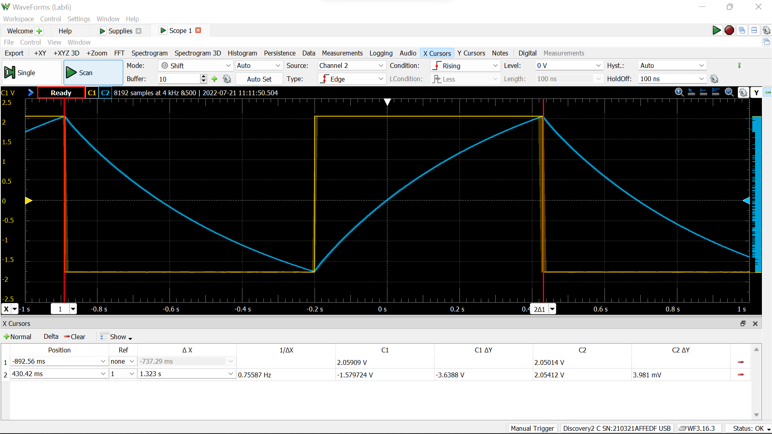

Figure 1: Waveforms of V1(t) and V2(t) from task 1 part A (Original circuit)

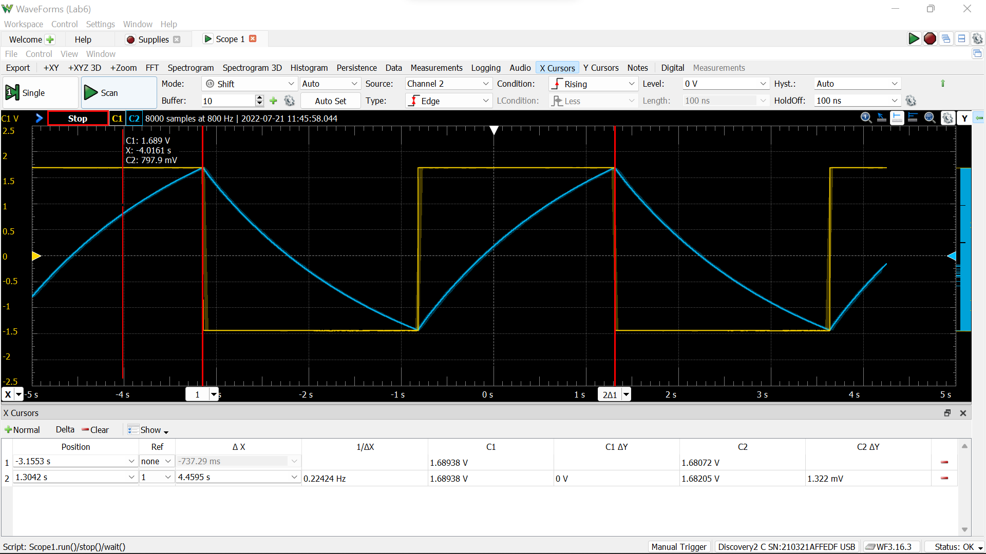

Figure 2: Waveforms of V1(t) and V2(t) from task 2 part A (Original circuit but using potentiometer for R1 and R2; 1 Hz)

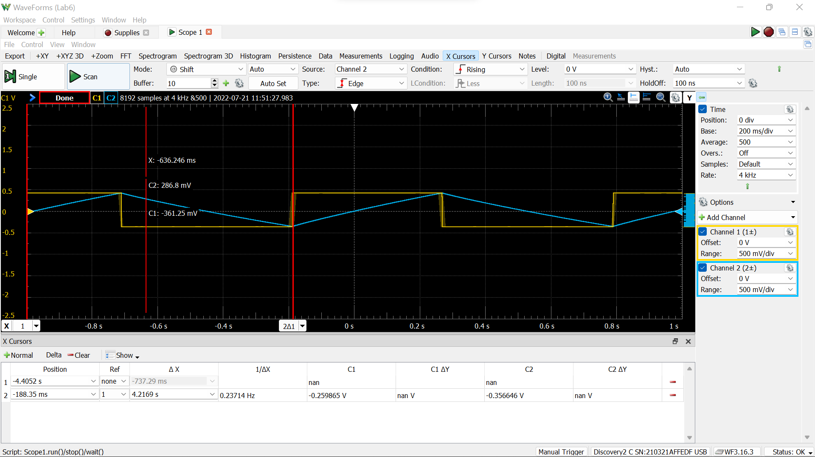

Figure 3: Waveforms of V1(t) and V2(t) from task 2 part C (uses potentiometer, R is halved, and frequency is about 1 Hz)

1. **Sample Calculations**

$γ = \frac{R_{2}}{R_{1}+R_{2}}$

Equation 1: Voltage division ratio

$V_{1}=γV_{out}$

Equation 2: Voltage division formula

$V_{2}(t)=V_{sat}+(V_{2}(0)-V_{sat})e^{-t/RC}$

Equation 3: Solution to equation for V2 when V2 < V1

$V_{2}(t)={-V}_{sat}+(V_{2}(0)-V_{sat})e^{-t/RC}$

Equation 4: Solution to equation for V2 when V2 > V1

$t=-τln(\frac{1-γ}{1+γ})$

Equation 5: Time at which V2 = V1

$f_{o}=-\frac{1}{2τln(\frac{1-γ}{1+γ})}$

Equation 6: Frequency of the periodic waveforms V1 and V2

$τ=RC$

Equation 7: Time constant

$X_{rms}=\sqrt{\frac{1}{T_{O}}\int_{T_{O}}{}x^{2}(t)dt}$

Equation 8: Root-Mean-Square (RMS) Voltage

The equations above were used to choose component values of R, C, R1, and R2 for an oscillating circuit that oscillates at 0.5 Hz. First, chose values of R1 and R2 that add to about 10 kiloohms. Then, pick value of C or R and uses the equations (616 and 7 above) to solve for the other one.

Check the actual frequency of the oscillation. Then find the peak-to-peak voltage as the difference between the lowest and highest voltage. Finally, use equation 8 to find the RMS voltage.

1. **Discussion**

During prelab, the ideal values were chosen to be: R1 = 5.1 kiloohms, R2 = 5.1 kiloohms, R = 50 kiloohms, and C = 10 microfarads. The ideal values were: actual frequency of oscillation was 0.910236 Hz, peak-to-peak voltage = 3.596 V, and RMS voltage value = 1.2714 V.

However, during the lab, the measured values were: actual frequency of oscillation = 0.75587 Hz, peak-to-peak voltage = 3.6295 V, and RMS voltage = 1.2832 V. The actual values used of R1, R2, R, and C are shown above in table 2. Based on lab 4, the actual saturation voltage of the operational amplifier is assumed to be 3.596 V.

The calculated values are different from the actual values. The measured actual frequency of oscillation is lower, the measured peak-to-peak voltage is slightly higher, and the RMS voltage is slightly higher.

A major reason for the differences between measured and ideal values could be from the real components of R1, R2, R, and C, used were not actually ideal values. Furthermore, the equation for frequency may be slightly incorrect since it was derived for ideal operational amplifiers, but the amplifiers used are non-ideal. These differences could help explain the reason why the prelab values are different to the measured values.

1. **Conclusion**

During this lab, I built an oscillating operational amplifier circuit. Through the process, I gained practice building circuits, and learned about how different actual non-ideal results are from predicted ideal values.